5.Performing basic CRUD operation(create,update,read,delete)on db records.

1.CRUD Operations in SQL
create table users1(
id integer primary key,
name text,
email text
);
show tables;



CREATE (Insert a record)
insert into users1 (id,name,email) values (1,'neha', 'jainneha@gmail.com'),('2','samir', 'aaryasamir@gmail.com');



READ (Retrieve data)
select*from users1;
select*from users1 where id=1;


UPDATE (Modify existing record)
update users1
set name='neha thakare',email='nehathakare@gmail.com'
where id=1;
select*from users1;

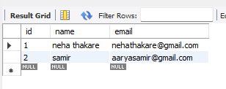

DELETE (Remove a record)
delete from users1 where id=1;
select*from users1;



